Project Report
Title: Fibonacci Number Detector
Project Number – 12
Section – KOC07
Group Name – Team DND
Subject – Python

As a Code based project for the Course
INT 108
By
Name Registration no. Roll no.
Channa Datta 12220799 B36
Nikhil Pratap 12220890 B37
Daksh 12221314 B38

Submitted To Ayushi mam
Lovely Professional University
Python code:-
n=int(input("Enter the Number: "))
c=0
a=1
b=1
if n==0 or n==1:
print("Yes......It is a Fibonacci number")
else:
while c<n:
c=a+b
b=a
a=c
if c==n:
print("Yes......It is a Fibonacci Number")
else:
print("No......It is Not a Fibonacci Number")

Project screenshot
Code:-
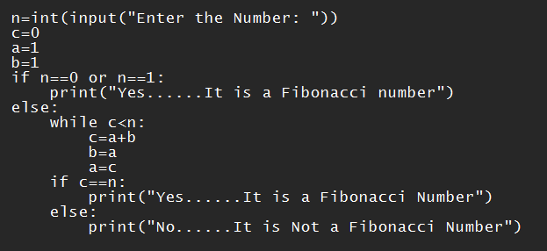
Result:-
